numpy task(np)
1.Create arr=np.arrange (1,13)conevert it into a 3 cross 4 cross matrix?
import numpy as np
arr = np.arange (1,13)
matrix = arr.reshape (3,4)
print(matrix)
OUTPUT:
[[ 1 2 3 4]
[ 5 6 7 8]
[ 9 10 11 12]]
2.Flatten the matrix?
print (matrix.flatten())
OUTPUT:
[ 1 2 3 4 5 6 7 8 9 10 11 12]
3.Multiply every element by 5?
print (matrix * 5)
OUTPUT:
[[ 5 10 15 20]
[25 30 35 40]
[45 50 55 60]]
4.Find sum,mean,max,min and standard deviation?
print(np.sum(matrix))
print(np.mean(matrix))
print(np.max(matrix))
print(np.min(matrix))
print(np.std(matrix))
OUTPUT:
78
6.5
12
1
3.452052529534663
5.create 2 cross 2 matrix and perform addition element wise multiplication and matrix multiplication?
import numpy as np
a = np.array([[3,2],[1,4]])
b = np.array([[4,2],[2,5]])
print (a+b)
print (a*b)
print (a@b)
OUTPUT:
[[7 4]
[3 9]]
[[12 4]
[ 2 20]]
[[16 16]
[12 22]]

PANDAS
1.Create a series containing 10,20,30,40,50?
import pandas as pd
s = pd.Series([10,20,30,40,50])
print(s)
OUTPUT:
0 10
1 20
2 30
3 40
4 50
dtype: int64
2.Create a series with custom index apple banana orange?
import pandas as pd
s = pd.Series([10,20,30],index=["apple","banana","orange"])
print(s)
OUTPUT:
apple 10
banana 20
orange 30
dtype: int64
3.Create the following dataframe?
Name AGE CITY
Aasha 21 chennai
Raghul 24 bangalore
Priya 23 hyderabath

import pandas as pd
d ={
"name":["aasha","raghul","priya"],
"age":[21,24,23],
"city":["chennai","bangalore","hyderabath"]
}
df = pd.DataFrame(d)
print(df)
OUTPUT:
name age city
0 aasha 21 chennai
1 raghul 24 bangalore
2 priya 23 hyderabath
4.Load a csv file called students,csv?
import pandas as pd
df = pd.read_csv("students.csv")
print(df)
OUTPUT:
Name Age City salary mark
0 john 25 chennai 35000 85
1 david 30 mumbai 45000 80
2 sara 28 delhi 40000 79
5.Display first 5 rows and last 5 rows?
import pandas as pd
df = pd.read_csv("students.csv")
print(df.head())
print(df.tail())
OUTPUT:
Name Age City salary mark
0 john 25 chennai 35000 85
1 david 30 mumbai 45000 80
2 sara 28 delhi 40000 79
3 aarthi 24 namakkal 100000 99
4 ajith 25 namakkal 20000 70
Name Age City salary mark
2 sara 28 delhi 40000 79
3 aarthi 24 namakkal 100000 99
4 ajith 25 namakkal 20000 70
5 nikesh 23 coimbatore 80000 50
6 dhivya 26 chennai 90000 90
First 5 rows head last 5 rows tail
6.Find no of rows and columns ?
import pandas as pd
df = pd.read_csv("students.csv")
print(df.shape)
OUTPUT:
(7, 5)
7.Display all column names?
import pandas as pd
df = pd.read_csv("students.csv")
print(df.columns)
OUTPUT:
Index(['Name', 'Age', 'City', 'salary', 'mark'], dtype='str')
8.Find the datatype of every columns?
import pandas as pd
df = pd.read_csv("students.csv")
print(df.dtypes)
OUTPUT:
Name str
Age int64
City str
salary int64
mark int64
dtype: object
9.Generate the statistical summery?
import pandas as pd
df = pd.read_csv("students.csv")
print(df.describe())
OUTPUT:
Age salary mark
count 7.000000 7.000000 7.000000
mean 25.857143 58571.428571 79.000000
std 2.410295 30918.479603 15.705625
min 23.000000 20000.000000 50.000000
25% 24.500000 37500.000000 74.500000
50% 25.000000 45000.000000 80.000000
75% 27.000000 85000.000000 87.500000
max 30.000000 100000.000000 99.000000
10.Display the random 3 rows?
import pandas as pd
df = pd.read_csv("students.csv")
print(df.sample(3))
OUTPUT:
Name Age City salary mark
5 nikesh 23 coimbatore 80000 50
1 david 30 mumbai 45000 80
0 john 25 chennai 35000 85
11.Find how many students belog to each city using value_count
import pandas as pd
df = pd.read_csv("students.csv")
print(df["City"].value_counts())
OUTPUT:
chennai 2
namakkal 2
mumbai 1
delhi 1
coimbatore 1
Name: count, dtype: int64
TASK 3:
1.Display only the name column?
import pandas as pd
df = pd.read_csv("students.csv")
print(df["Name"])
OUTPUT:
0 john
1 david
2 sara
3 aarthi
4 ajith
5 nikesh
6 dhivya
2.Display name and salary columns?
import pandas as pd
df = pd.read_csv("students.csv")
print(df[["Name","salary"]])
OUTPUT:
Name salary
0 john 35000
1 david 45000
2 sara 40000
3 aarthi 100000
4 ajith 20000
5 nikesh 80000
6 dhivya 90000
3.Display students whose mark are greter than 80?
import pandas as pd
df = pd.read_csv("students.csv")
print(df[df["mark"]>80])
OUTPUT:
Name Age City salary mark
0 john 25 chennai 35000 85
3 aarthi 24 namakkal 100000 99
6 dhivya 26 chennai 90000 90
4.Display employee from chennai?
import pandas as pd
df = pd.read_csv("students.csv")
print(df[df["City"]=="chennai"])
OUTPUT:
Name Age City salary mark
0 john 25 chennai 35000 85
6 dhivya 26 chennai 90000 90
5.Sort the dataset based on salary in descending order?
import pandas as pd
df = pd.read_csv("students.csv")
print(df.sort_values(by="salary",ascending=False))
OUTPUT:
Name Age City salary mark
3 aarthi 24 namakkal 100000 99
6 dhivya 26 chennai 90000 90
5 nikesh 23 coimbatore 80000 50
1 david 30 mumbai 45000 80
2 sara 28 delhi 40000 79
0 john 25 chennai 35000 85
4 ajith 25 namakkal 20000 70
6.Add a bonus column equal to 15 % of salary?
import pandas as pd
df = pd.read_csv("students.csv")
df["bonus"]=df["salary"]* 0.15
print(df)
OUTPUT:
Name Age City salary mark bonus
0 john 25 chennai 35000 85 5250.0
1 david 30 mumbai 45000 80 6750.0
2 sara 28 delhi 40000 79 6000.0
3 aarthi 24 namakkal 100000 99 15000.0
4 ajith 25 namakkal 20000 70 3000.0
5 nikesh 23 coimbatore 80000 50 12000.0
6 dhivya 26 chennai 90000 90 13500.0
TASK 4:
1.Find the missing values in the dataset?
import pandas as pd
df = pd.read_csv("students.csv")
print(df.isnull())
OUTPUT:
Name Age City salary mark
0 False False False False True
1 False False False False False
2 False False False False True
3 False False False False False
4 False False False False True
2.Count the number of missing values in each columns?
import pandas as pd
df = pd.read_csv("students.csv")
print(df.isnull().sum())
OUTPUT:
Name 0
Age 0
City 0
salary 0
mark 3
dtype: int64
3.Remove duplicate rows?
import pandas as pd
df = pd.read_csv("students.csv")
print(df.drop_duplicates())
OUTPUT:
Name age City salary mark
0 john 25 chennai 35000 NaN
1 david 30 mumbai 45000 80.0
2 sara 22 delhi 40000 79.0
3 aarthi 24 namakkal 100000 99.0
4 sowmi 25 namakkal 70 NaN
5 nikesh 23 coimbatore 80000 50.0
6 dhivya chennai 90000 90.0
4.convert the name column to uppercase?
import pandas as pd
df = pd.read_csv("students.csv")
df["Name"]=df["Name"].str.upper()
print(df)
OUTPUT:
Name age City salary mark
0 JOHN 25 chennai 35000 NaN
1 DAVID 30 mumbai 45000 80.0
2 SARA 22 delhi 40000 79.0
3 AARTHI 24 namakkal 100000 99.0
4 SOWMI 25 namakkal 70 NaN
5 NIKESH 23 coimbatore 80000 50.0
6 DHIVYA chennai 90000 90.0
5.Replace madras with Chennai?
import pandas as pd
df = pd.read_csv("students.csv")
df["City"]=df["City"].replace("chennai","madras")
print(df)
OUTPUT:
Name age City salary mark
0 john 25 madras 35000 NaN
1 david 30 mumbai 45000 80.0
2 sara 22 delhi 40000 79.0
3 aarthi 24 namakkal 100000 99.0
4 sowmi 25 namakkal 70 NaN
5 nikesh 23 coimbatore 80000 50.0
6 dhivya madras 90000 90.0
6.Find the average salary for each city with groupby
import pandas as pd
df = pd.read_csv("students.csv")
print(df.groupby("City")["salary"].mean())
OUTPUT:
City
chennai 62500.0
coimbatore 80000.0
delhi 40000.0
mumbai 45000.0
namakkal 50035.0
Name: salary, dtype: float64
7.Replace missing age values with average age?
import pandas as pd

df = pd.read_csv("students.csv")
df["age"] = df["age"].fillna(df["age"].mean())
print(df)
OUTPUT:
id Name age City salary mark
0 1 john 25.0 chennai 35000 NaN
1 2 david 30.0 mumbai 45000 80.0
2 3 sara 22.0 delhi 40000 79.0
3 4 aarthi 25.0 namakkal 100000 99.0
4 5 sowmi 25.0 namakkal 70 NaN
5 6 nikesh 23.0 coimbatore 80000 50.0
6 7 dhivya 25.0 chennai 90000 90.0
8.Merge two dataframes using the id column?
import pandas as pd
students = pd.read_csv("students.csv")
teachers = pd.read_csv("Teachers.csv")
merge = pd.merge(students, teachers, on="id")
print(merge)
OUTPUT:
id Name age City salary mark grade
0 1 john 25.0 chennai 35000 NaN A
1 2 david 30.0 mumbai 45000 80.0 B
2 3 sara 22.0 delhi 40000 79.0 C
3 4 aarthi NaN namakkal 100000 99.0 D
4 5 sowmi 25.0 namakkal 70 NaN E
5 6 nikesh 23.0 coimbatore 80000 50.0 F
9.Create a dataframe with name,marks?
import pandas as pd
data={
"name":["Elsa","aana","olaf"],
"marks":[90,89,70]
}
df = pd.DataFrame(data)
print(df)
OUTPUT:
name age
0 elsa 79
1 aana 90
2 olaf 82
10.Covert all student names to uppercase?
import pandas as pd
data={
"name":["Elsa","aana","olaf"],
"marks":[90,89,70]
}
df = pd.DataFrame(data)
df["name"]=df["name"].str.upper()
print(df)
OUTPUT:
name age
0 ELSA 79
1 AANA 90
2 OLAF 82
11.Create a salary column and increase it by 20%?
import pandas as pd
data={
"name":["elsa","aana","olaf"],
"salary":[30000,20000,10000]
}
df = pd.DataFrame(data)
df["salary"] = df["salary"]*1.20
print(df)
OUTPUT:
name salary
0 elsa 36000.0
1 aana 24000.0
2 olaf 12000.0

Data visualization
1.Create a line graph showing marks of five students?
x = ["aarthi","rigna","sowmi","river","fire"]
y = [90,70,60,82,98]
plt.plot(x,y)
plt.show()
OUTPUT:
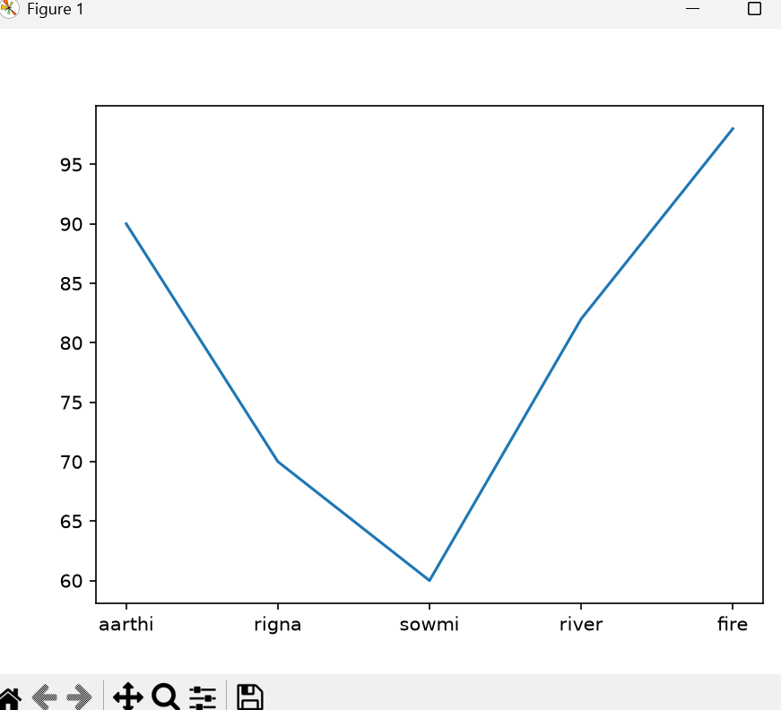

2.Plot monthly temperature?
import matplotlib.pyplot as plt
x = ["jan","feb","march","april","may"]
y = [25,23,24,22,28]
plt.plot (x,y)
plt.show()
output:
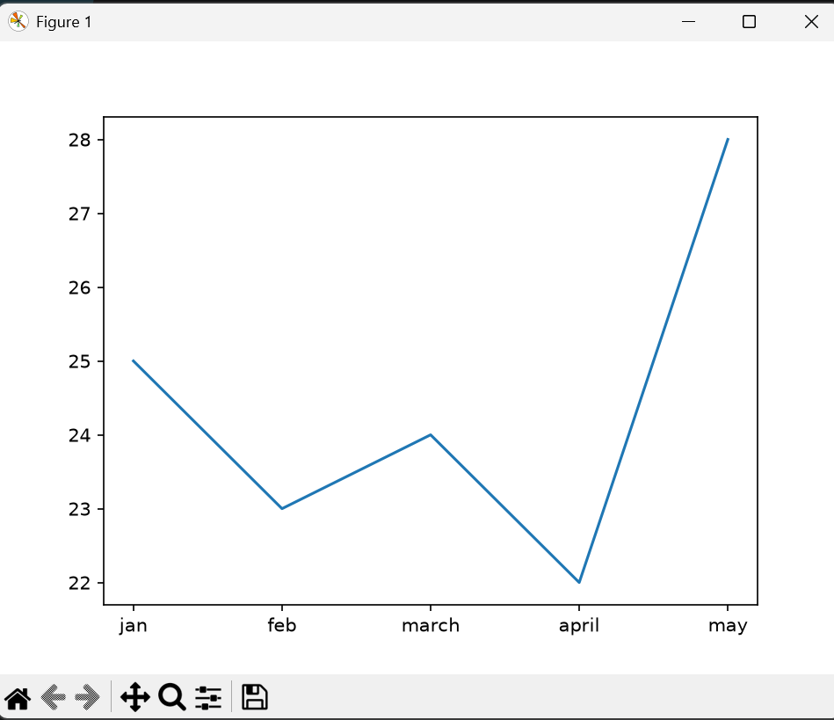
3.Add title x-axis label?
import matplotlib.pyplot as plt
x = ["jan","feb","march","april","may"]
y = [25,23,24,22,28]
plt.plot(x, y)
plt.xlabel("Months")
plt.show()
output:
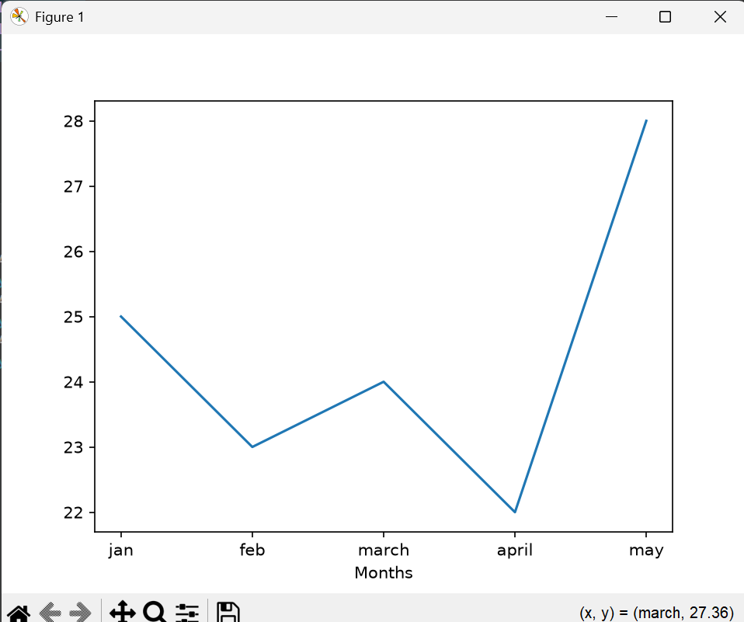
4.display grid?
import matplotlib.pyplot as plt
x = ["jan","feb","march","april","may"]
y = [25,23,24,22,28]
plt.plot(x, y)
plt.xlabel("Months")
plt.ylabel("Temperature")
plt.grid()
plt.show()
output:
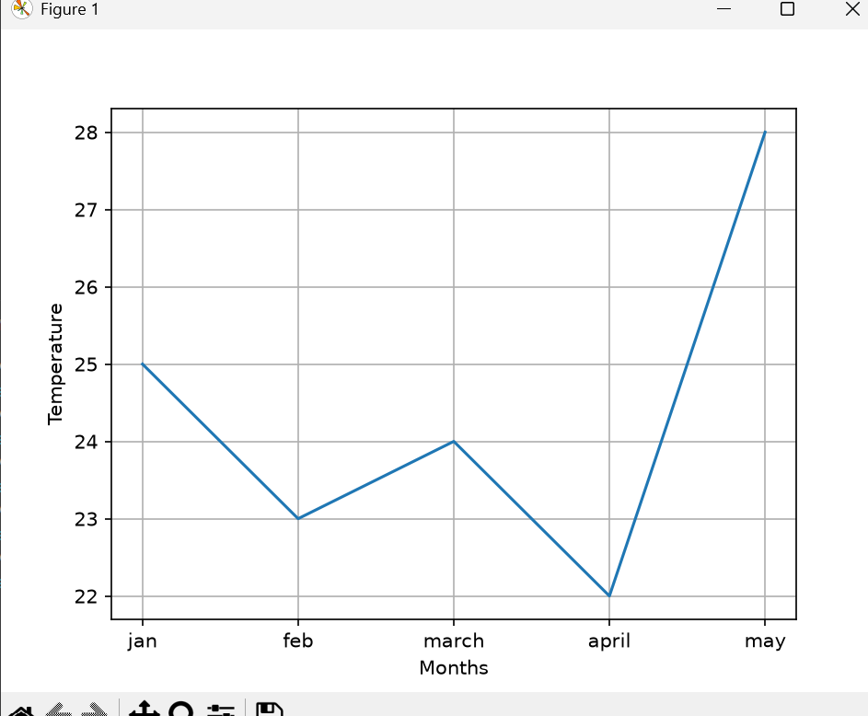
5.change color linstyle?
x = ["jan","feb","march","april","may"]
y = [25,23,24,22,28]
plt.plot(x, y, color="red", linestyle="--")
plt.xlabel("Months")
plt.ylabel("Temperature")
plt.grid()
plt.show()
output:
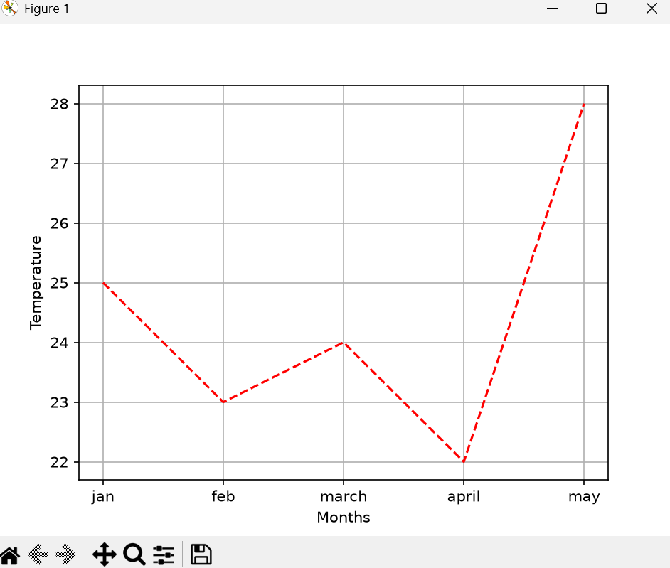
6.Different types of charts?
Line plot:
import matplotlib.pyplot as plt
x = ["jan","feb","march","april","may"]
y = [25,23,24,22,28]
plt.plot(x,y)
plt.xlabel("month")
plt.ylabel("temprature")
plt.grid()
plt.show()
output:
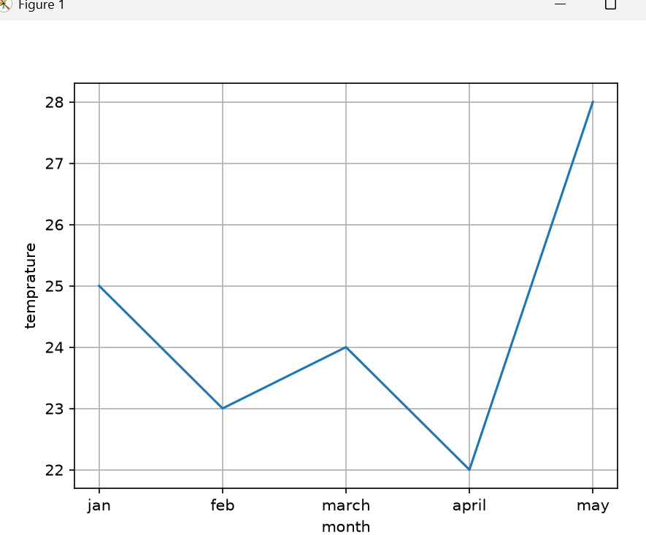
Bar chat:
import matplotlib.pyplot as plt
x = ["jan","feb","march","april","may"]
y = [25,23,24,22,28]
plt.bar(x,y)
plt.xlabel("month")
plt.ylabel("temprature")
plt.show()
output:
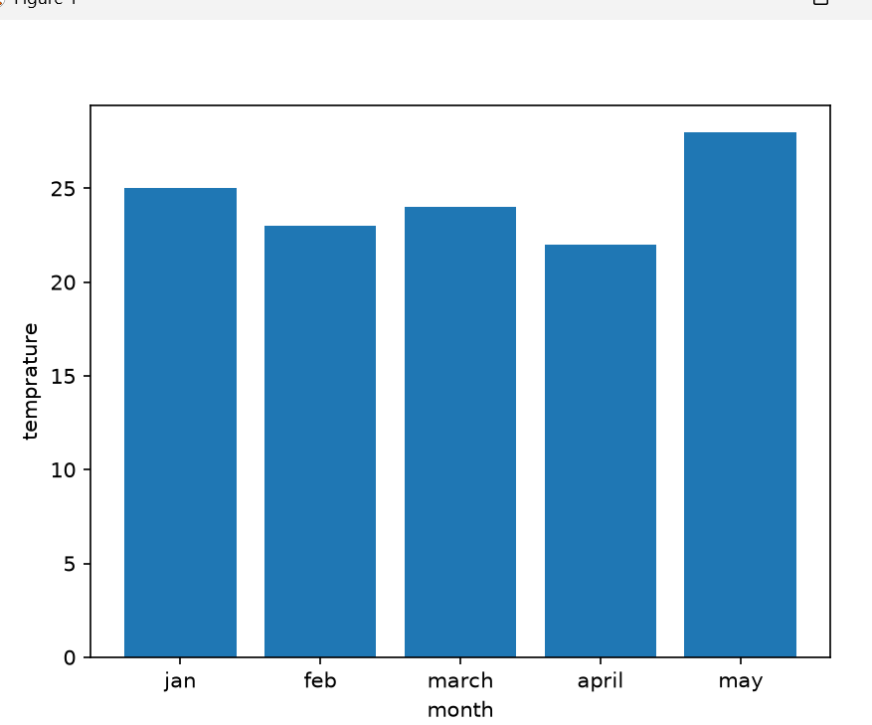
Pie chart:
import matplotlib.pyplot as plt
x = ["jan","feb","march","april","may"]
y = [25,23,24,22,28]
plt.pie(y,labels=x,autopct="%1.1f%%")
plt.title("temperature")
plt.show()
output:
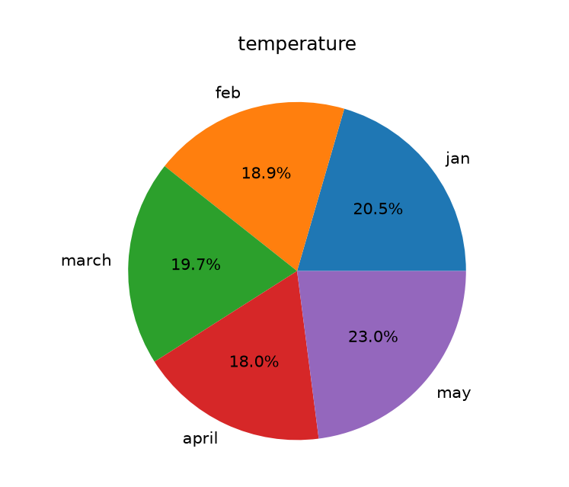
Histogram:
import matplotlib.pyplot as plt
y = [25, 23, 24, 22, 28]
plt.hist(y)
plt.xlabel("Temperature")
plt.ylabel("Frequency")
plt.title("Temperature Histogram")
plt.show()
output:
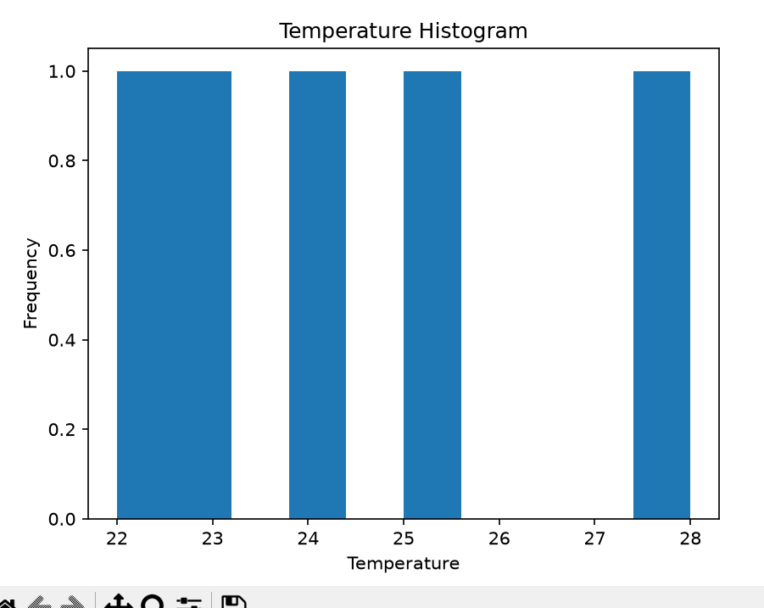
Scattler plot:
import matplotlib.pyplot as plt
x = ["jan","feb","march","april","may"]
y = [25,23,24,22,28]
plt.scatter(x,y)
plt.xlabel("month")
plt.ylabel("temprature")
plt.show()
output:
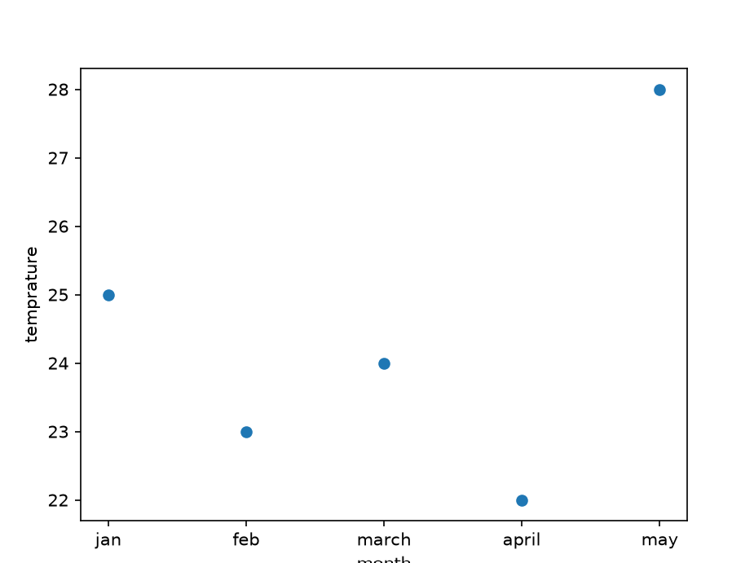
1.Create a lineplot showing monthly electricity consumption?
import matplotlib.pyplot as plt
months = ["jan","feb","march","april","may","june"]
consumption = [120,125,130,147,111,290]
plt.plot(months,consumption)
plt.xlabel("months")
plt.ylabel("consumption")
plt.title("Electricity consumption")
plt.show()
OUTPUT:
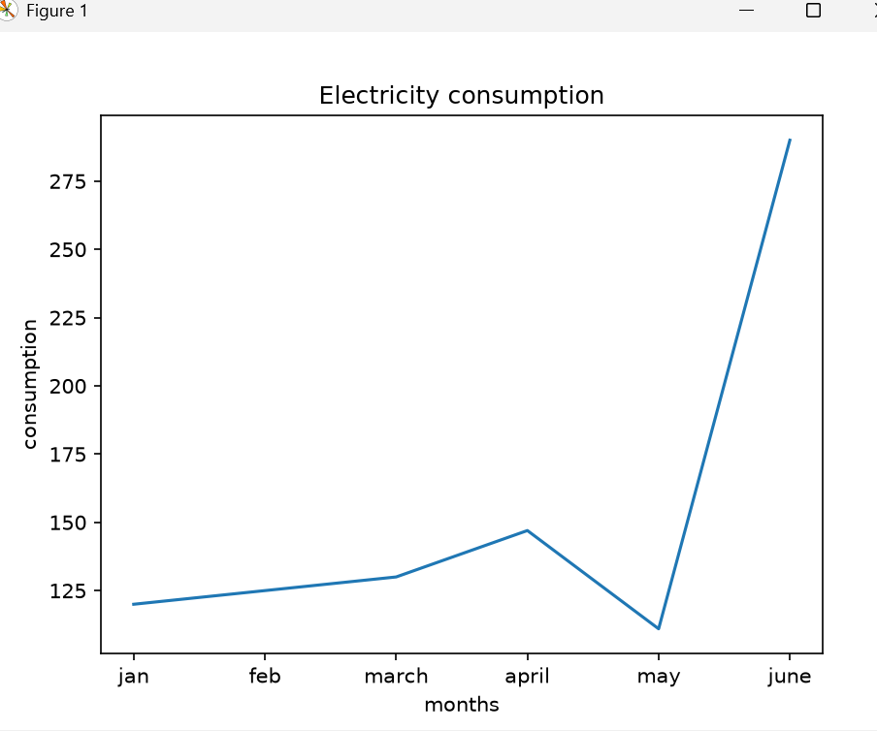
2.Create a barchart comparing five students marks?
import matplotlib.pyplot as plt
students = ["aarthi","river","fire","sowmi","supraja"]
marks = [99,92,87,70,56]
plt.bar(students,marks)
plt.xlabel("students")
plt.ylabel("marks")
plt.title("comaprison")
plt.show()
OUTPUT:
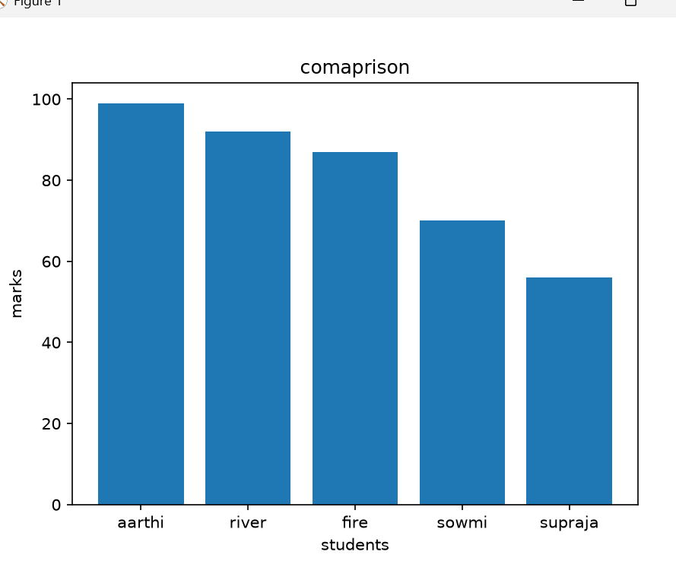
3.Create a horizontal barchart showing employee salarys?
import matplotlib.pyplot as plt
employee = ["arun","ajith","naveen","logu","nikesh"]
salary = [30000,23000,26000,80000,27000]
plt.barh(employee,salary)
plt.xlabel("employee")
plt.ylabel("salary")
plt.title("employee salary")
plt.show()
OUTPUT:
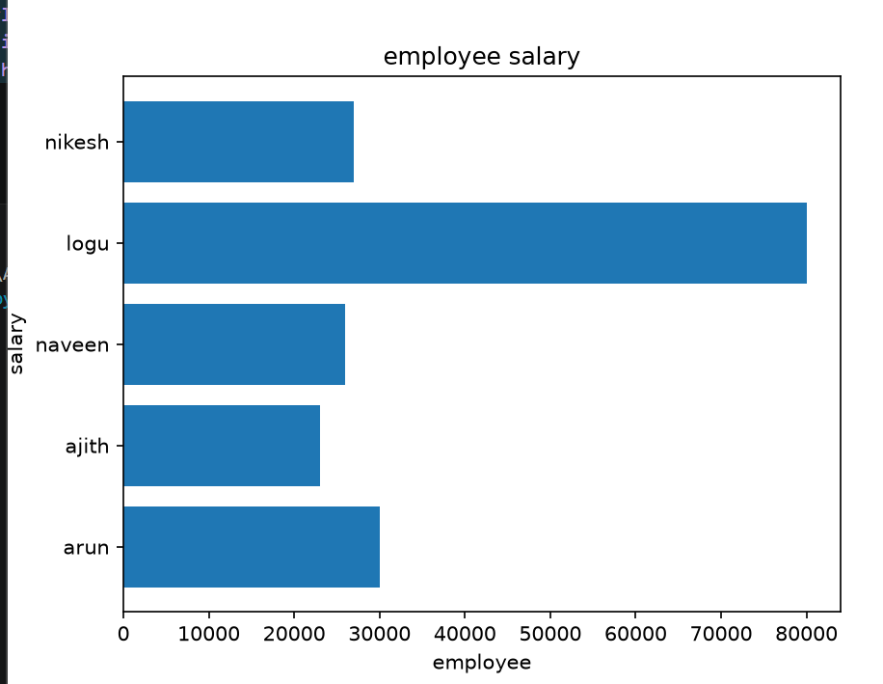
4.Create a pie chart showing category expenses?
Salary,rent,marketing,electricity:
import matplotlib.pyplot as plt
categories = ["salary","rent","marketing","electricity"]
expenses = [30000,17000,20000,5900]
plt.pie(expenses,labels=categories,autopct="%1.1f%%")
plt.title("category expenses")
plt.show()
OUTPUT:
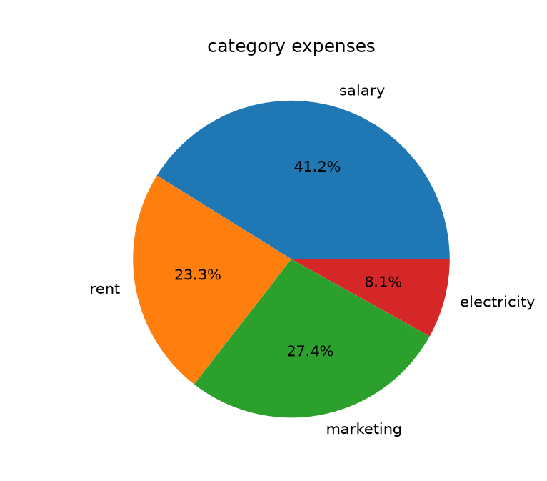
5.Create a histogram for 30 student marks?
import matplotlib.pyplot as plt
Marks = [85,72,90,65,78,88,92,55,60,75,
80,70,95,68,82,77,89,91,50,62,
74,86,93,66,79,84,58,73,87,69]
plt.hist(Marks,bins=5)
plt.title("students marks")
plt.show()
OUTPUT:
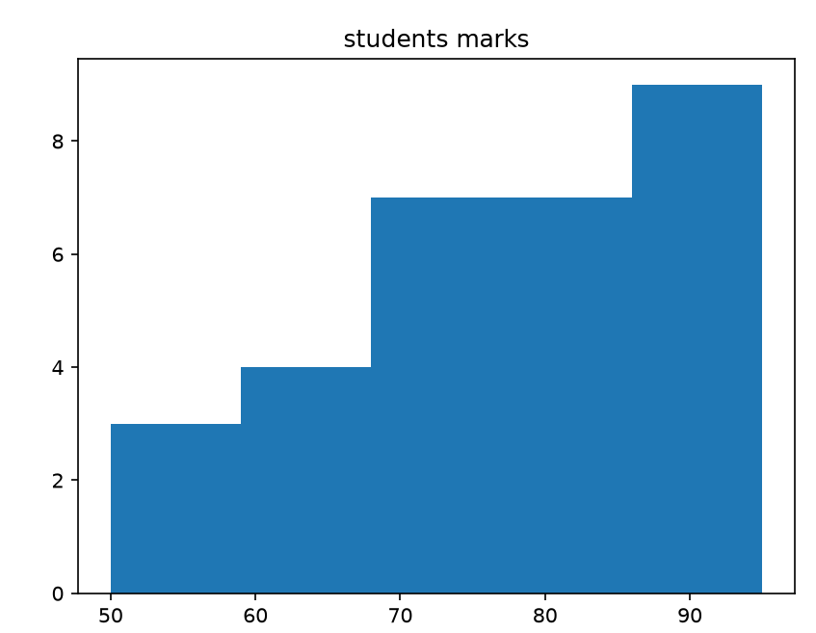
6.Create a scatter plot showing study hours vs marks?
import matplotlib.pyplot as plt
hours = [1,2,3,4,5,6]
marks = [90,50,70,82,33,89]
plt.scatter(hours,marks)
plt.xlabel("Study hours")
plt.ylabel("marks")
plt.title("student study")
plt.grid()
plt.show()
OUTPUT:
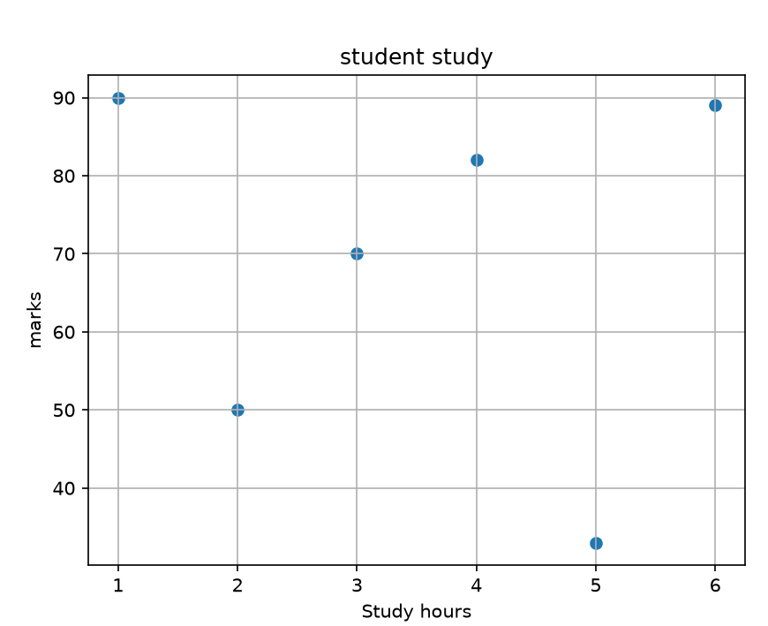
7.Compare sales of 2 components using two line plots in one graph?
import matplotlib.pyplot as plt
month = ["jan","feb","march","april","may"]
a = [200,300,400,500,210]
b = [110,120,130,140,150]
plt.plot(month,a,label = "A")
plt.plot(month,b,label = "B")
plt. xlabel("month")
plt. ylabel("sales")
plt.legend()
plt.grid()
plt.show()
OUTPUT:
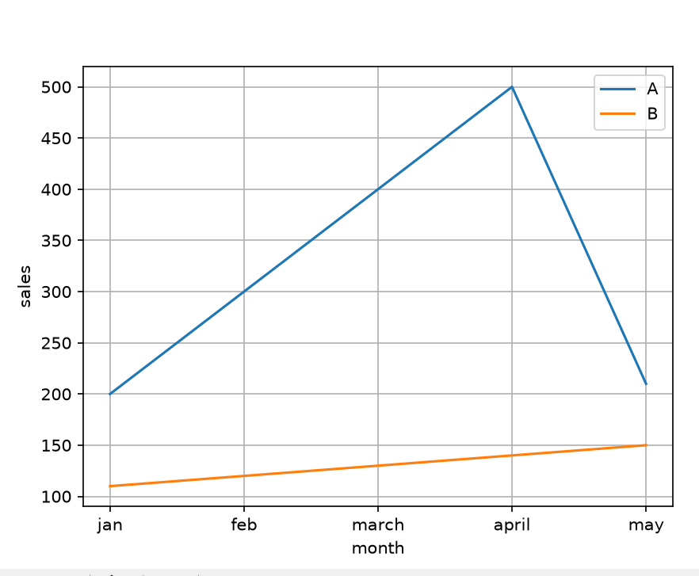
8.Create a subplot first barchart second pie chart?
import matplotlib.pyplot as plt
x = ["cat","dog","cow"]
y = [1,2,3]
plt.subplot(121)
plt.bar(x,y)
plt.subplot(122)
plt.pie(y,labels=x)
plt.show()
OUTPUT:
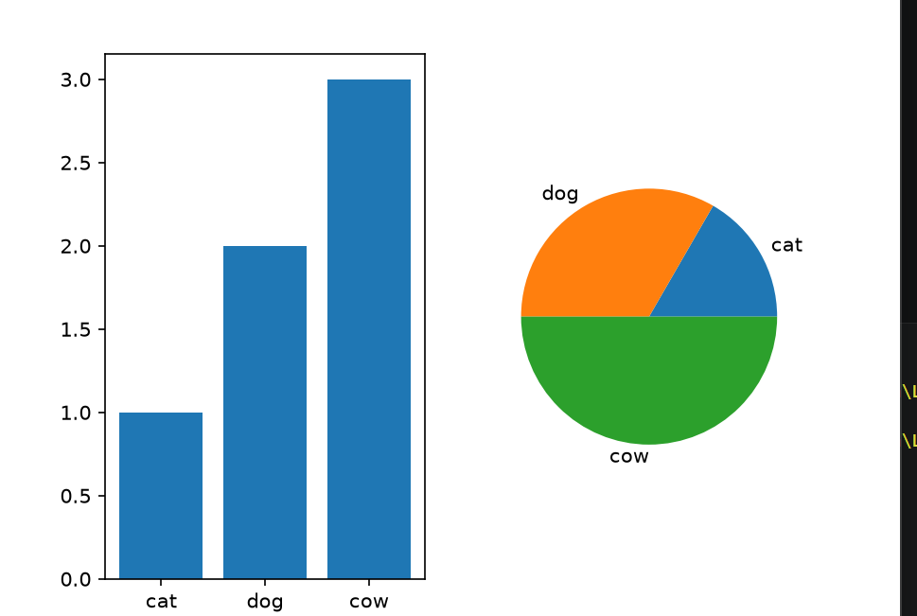

SEABORN
1.Install seaborn and import it?
Pip install seaborn
import seaborn as sns
import matplotlib.pyplot as plt
2.Load the iris data:
df = sns.load_dataset ("iris")
3.Display data inspection?
print(iris.head())
print(iris.info())
print(iris.describe())
4.Apply different seaborn themes and observe the change?
sns.set_theme(style="darkgrid")

sns.scatterplot(data=df, x="sepal_length", y="sepal_width", hue="species")

plt.title("Darkgrid Theme")
plt.show()
Output:
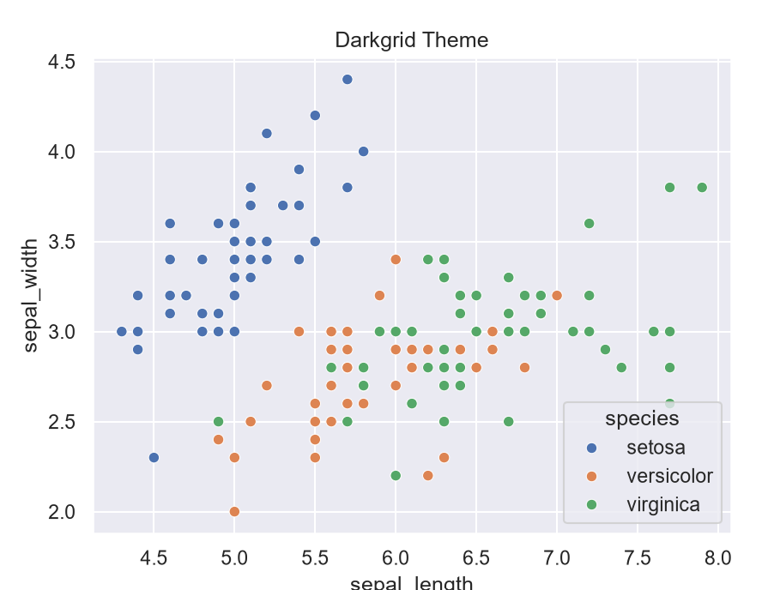
1.Load another dataset:
df = sns.load_dataset("penguins")
print(df.head())
2.Create a line plot and show any 2 columns plotted:
sns.lineplot(data=df, x="bill_length_mm", y="flipper_length_mm")
plt.title("line plot:bill_lenght_mm vs flipper_length_mm")
plt.show()
OUTPUT:
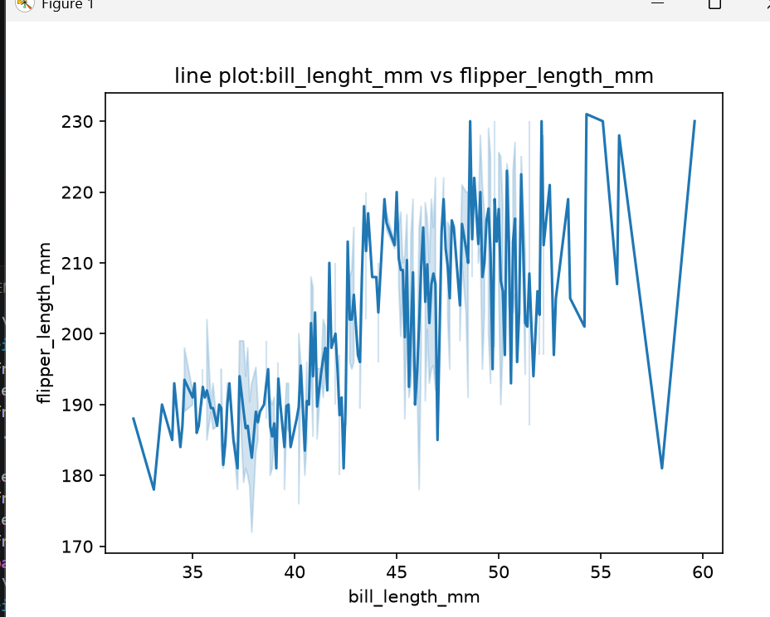

3.Create a barplot:
import seaborn as sns
import matplotlib.pyplot as plt
df = sns.load_dataset("tips")
print(df.head())
print(df.describe())
sns.barplot(data = df, x="day", y="total_bill", hue="sex")
plt.show()
OUTPUT:
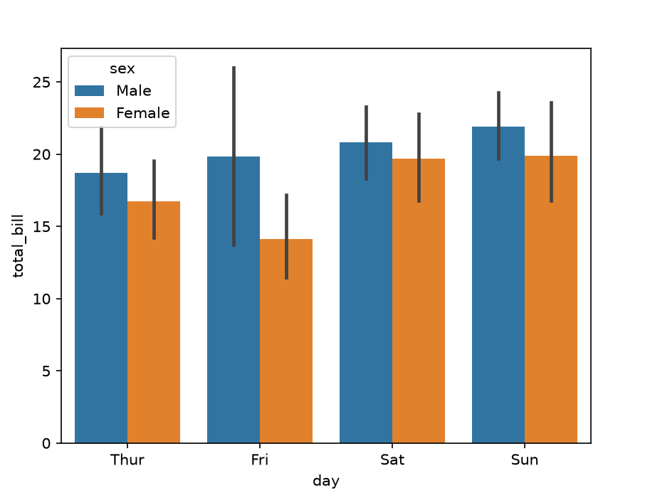
3.Create a countplot:
import seaborn as sns
import matplotlib.pyplot as plt
df = sns.load_dataset("diamonds")
print(df.head())
sns.countplot(data=df, x="cut",hue="color")
plt.show()
OUTPUT:
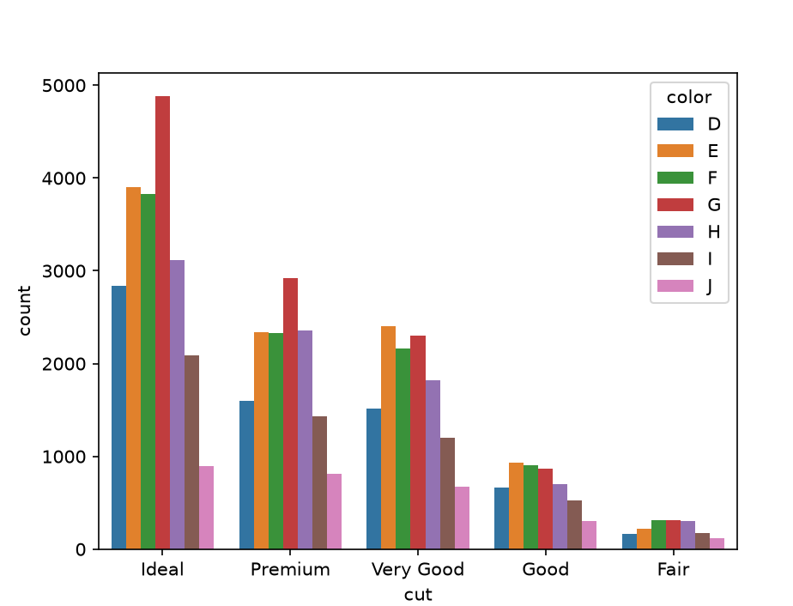
4.Create a scatterplot style,hue,size:
import seaborn as sns
import matplotlib.pyplot as plt
df = sns.load_dataset("iris")
print(df.head())
sns.scatterplot(data=df , x="sepal_length" , y="petal_length",hue="species",style="species",size="petal_width")
plt.show()
OUTPUT:
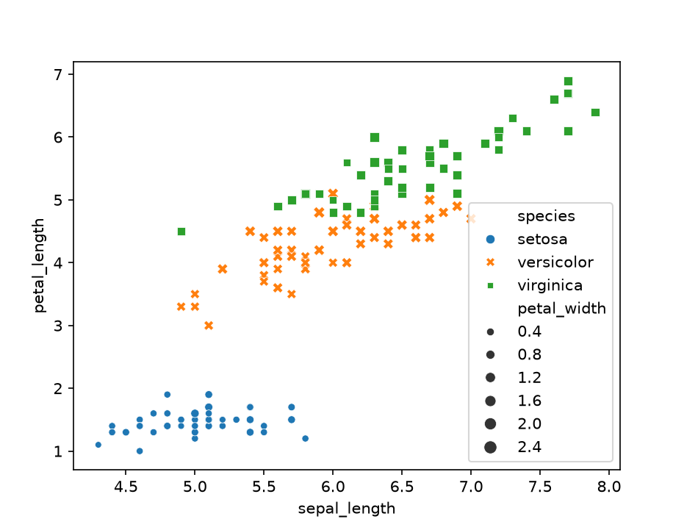
1.Load any dataset:
import seaborn as sns
import matplotlib.pyplot as plt
df = sns.load_dataset("flights")
2.Create a histogram for a column with bins:
print(df.head())
sns.histplot(data=df , x="passengers", bins=10)
plt.show()
output:
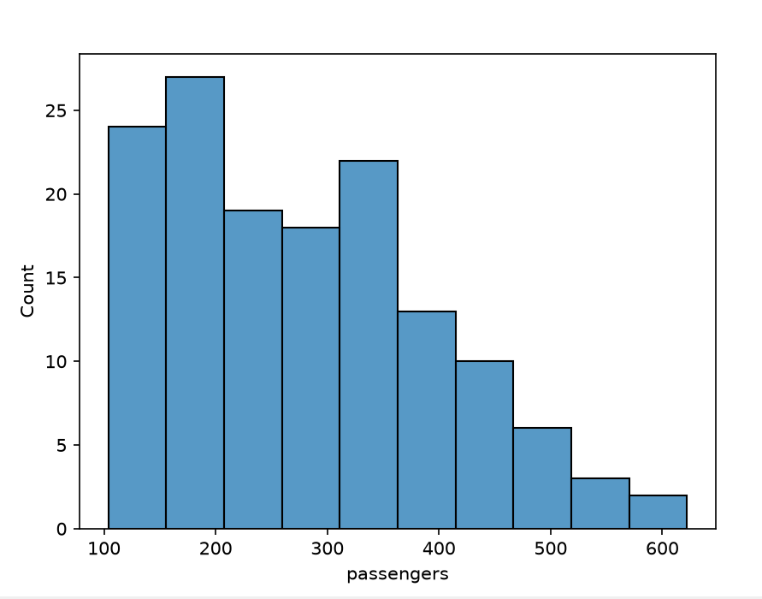4.create a filled kdeplot:
import seaborn as sns
import matplotlib.pyplot as plt
df = sns.load_dataset("titanic")
print(df.head())
sns.kdeplot(data=df, x="age", fill=True,hue ="sex")
plt.title("filled kde plot of age")
plt.show()
OUTPUT:
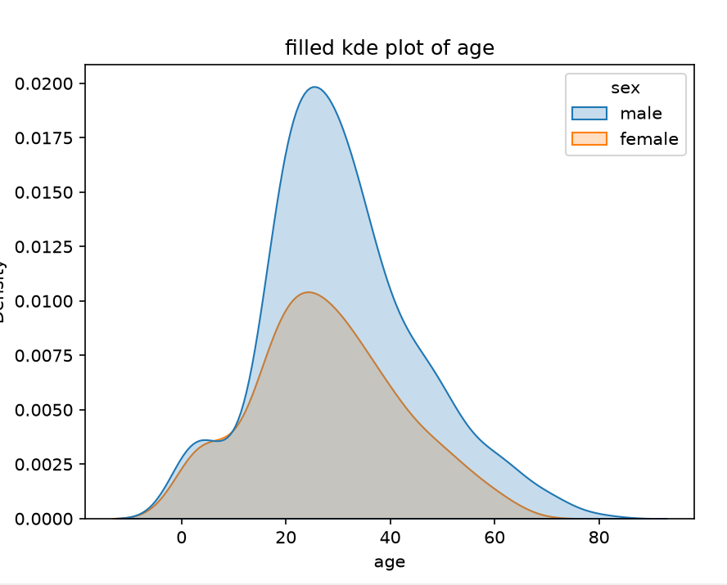
5.create a displot:
import seaborn as sns
import matplotlib.pyplot as plt
df = sns.load_dataset("iris")
sns.displot(data=df , x="sepal_length",fill=True,hue = "species")
plt.show()
OUTPUT:
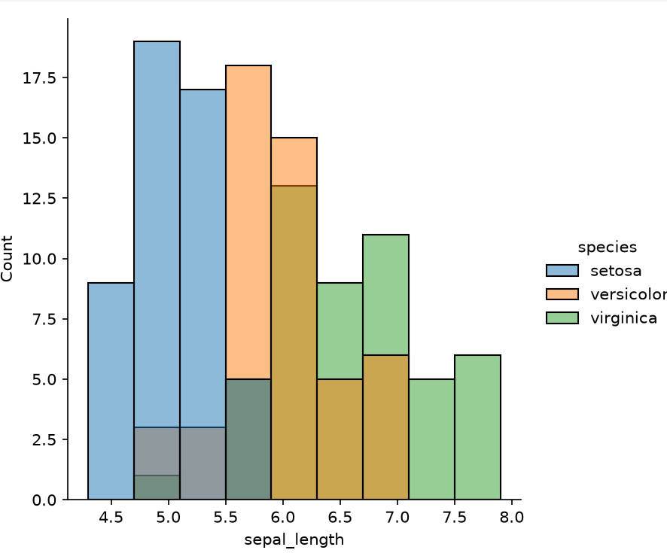
1.Create a boxplot with 2 columns:
import seaborn as sns
import matplotlib.pyplot as plt
df = sns.load_dataset("diamonds")
print (df.head())
sns.boxplot(data=df , x="cut", y="price",hue="color")
plt.title("box plot")
plt.show()
output:
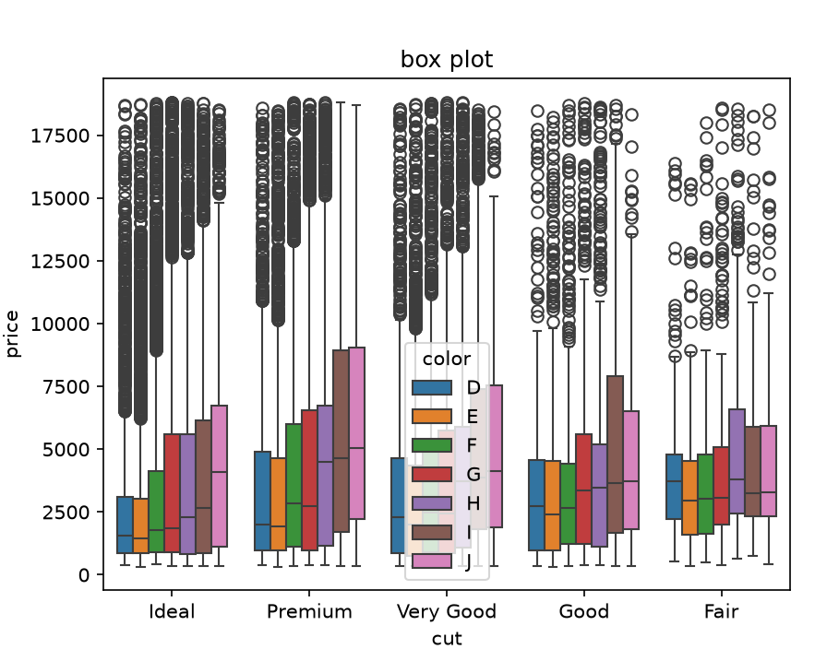
2.Create a violin plot:
df = sns.load_dataset("tips")
print(df.head())
sns.violinplot(data=df,x="total_bill", y="tip" ,fill=True, hue ="sex")
plt.show()
OUTPUT:
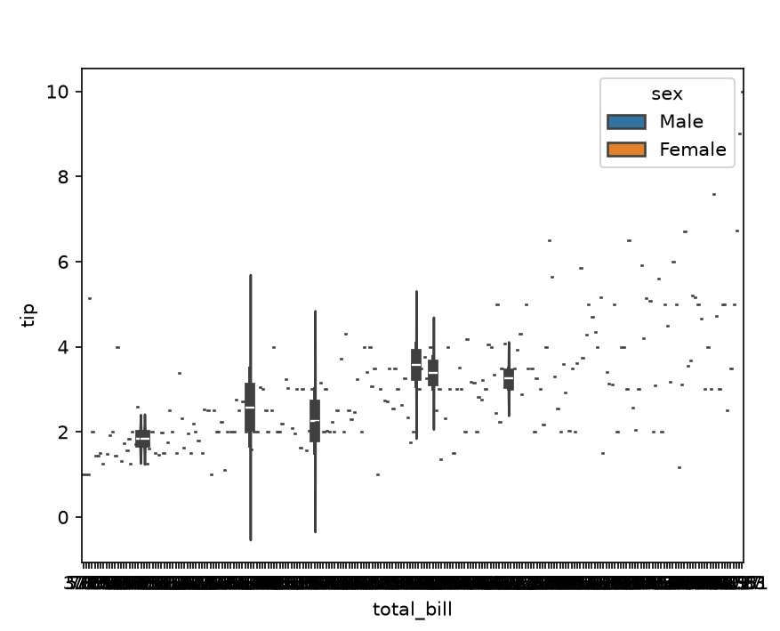
4.Create a stripplot with jitter:
import seaborn as sns
import matplotlib.pyplot as plt
df = sns.load_dataset("iris")
print(df.head())
sns.stripplot(data=df, x="sepal_length", y="sepal_width",jitter=True, hue="species")
plt.title("strip with jitter")
plt.show()
OUTPUT:
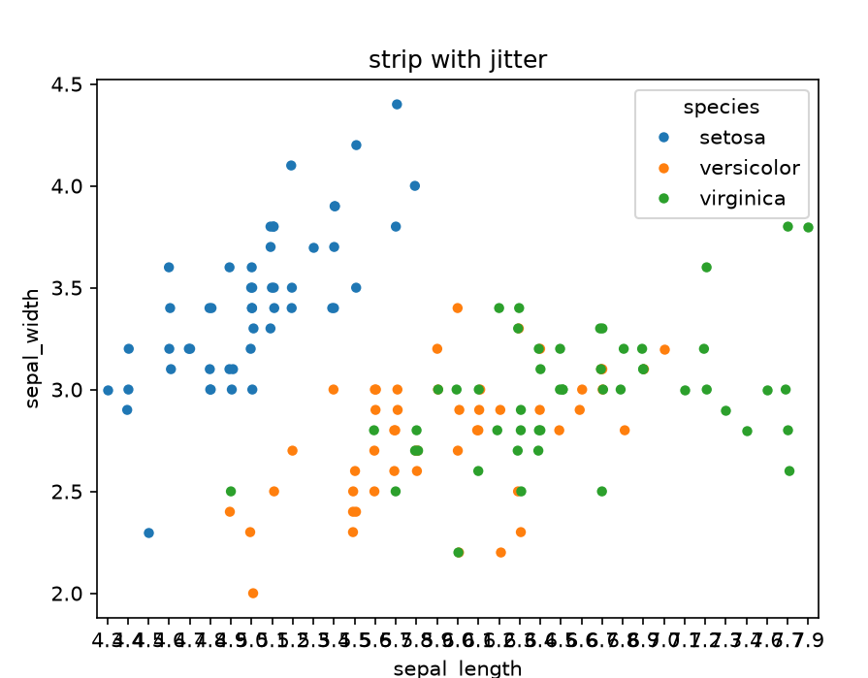
5.create a swarmplot:
import seaborn as sns
import matplotlib.pyplot as plt
df = sns.load_dataset("penguins")
print(df.head())
sns.swarmplot(data=df, x="bill_length_mm", y="flipper_length_mm",hue = "sex")
plt.show()

OUTPUT:
